***Experiment 2 Output***

In this experiment, a web application is deployed on a cloud server using AWS EC2, focusing on cloud deployment and infrastructure.

***Running Docker***

***Running AWS using Localstack***

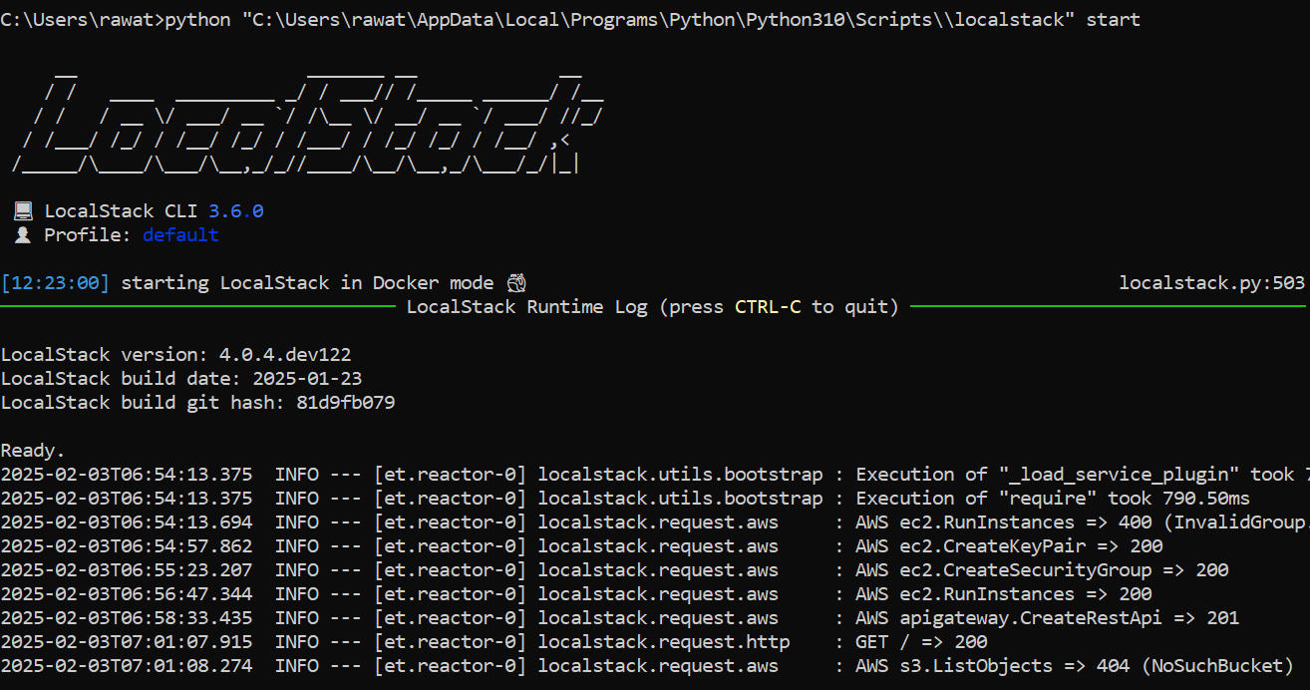

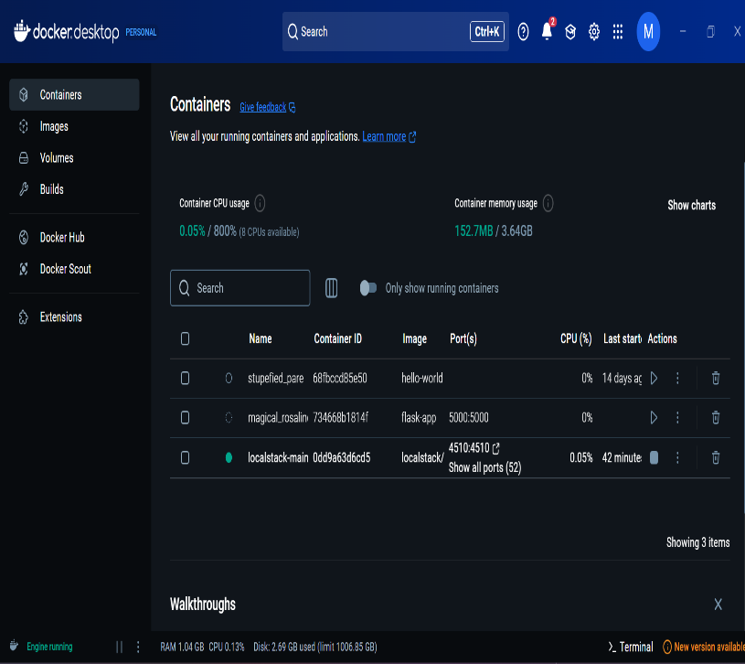

***Fig 2: Docker for Desktop in windows***

**Fig 1: Starting Localstack in the Console**

***Deploying a Flask App***

***Configuration and Resources***

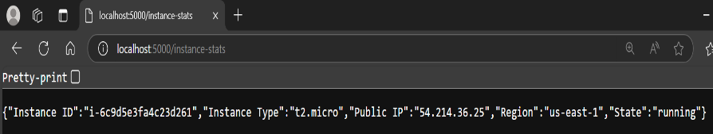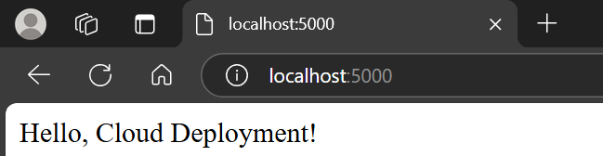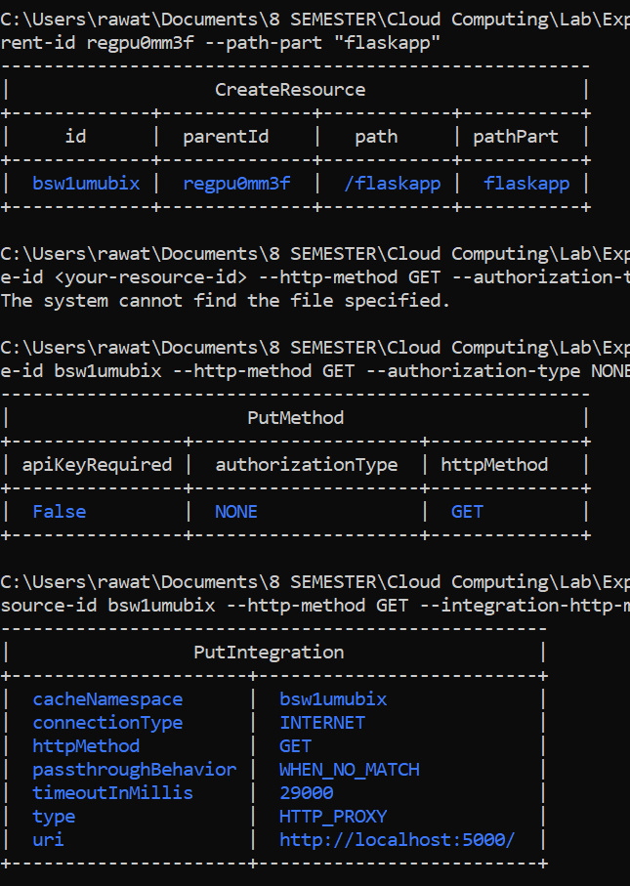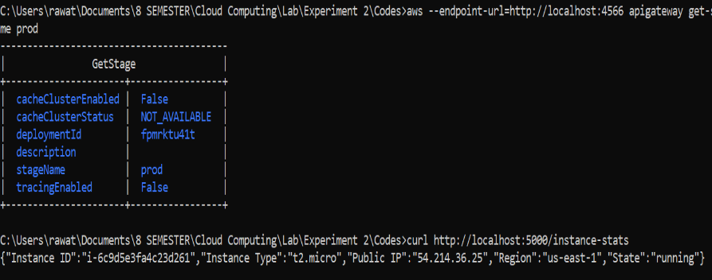

***Fig 5: Flask and Cloud Output***

***Fig 3: AWS New Instances and deployment of Flask App***

***Fig 4: Instance Id & Resources***